**DAILY ONLINE ACTIVITIES SUMMARY**

|  |  |  |  |  |  |  |  |
| --- | --- | --- | --- | --- | --- | --- | --- |
| **Date:** | **23/06/2020** | | | | **Name:** | **Anusha. K** | |
| **Sem & Sec** | **4th SEM 'A' Section** | | | | **USN:** | **4AL18CS009** | |
| **Online Test Summary** | | | | | | | |
| **Subject** | | **No test** | | | | | |
| **Max. Marks** | |  | | **Score** | |  | |
| **Certification Course Summary** | | | | | | | |
| **Course** | **Machine learning with python** | | | | | | |
| **Certificate Provider** | | | **greatlearning academy** | **Duration** | | | **10.5 hours** |
| **Coding Challenges** | | | | | | | |
| **Problem statement 1:Python Program to Split the array and add the first part to the end There is a given an array and split it from a specified position, and move the first part of array add to the end.**  **Problem statement 02:Write a C Program to Sort a stack using a temporary stack.** | | | | | | | |
| **Status: completed** | | | | | | | |
| **Uploaded the report in Github** | | | | **yes** | | | |
| **If yes Repository name** | | | | [**https://github.com/anusha20219/Lockdown-coding**](https://github.com/anusha20219/Lockdown-coding) | | | |
| **Uploaded the report in slack** | | | | **yes** | | | |

ONLINE TEST DETAILS: no test

Webinar: I attended the webinar organised by department of cse on the topic iot.

Certification course details: Today I attended certification course on the topic Machine learning with python.

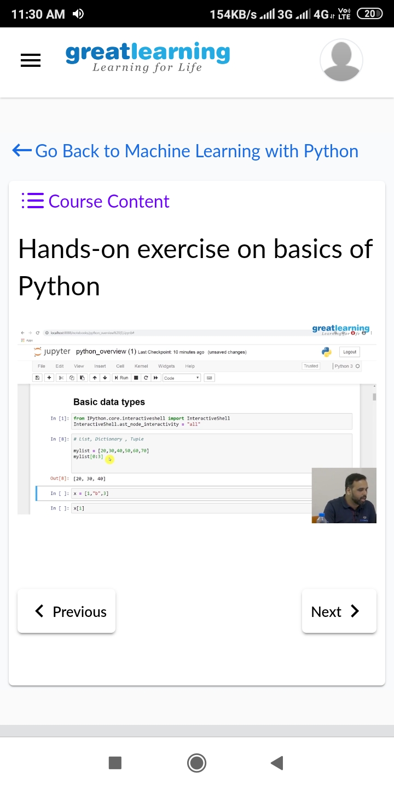

Coding challenge details:

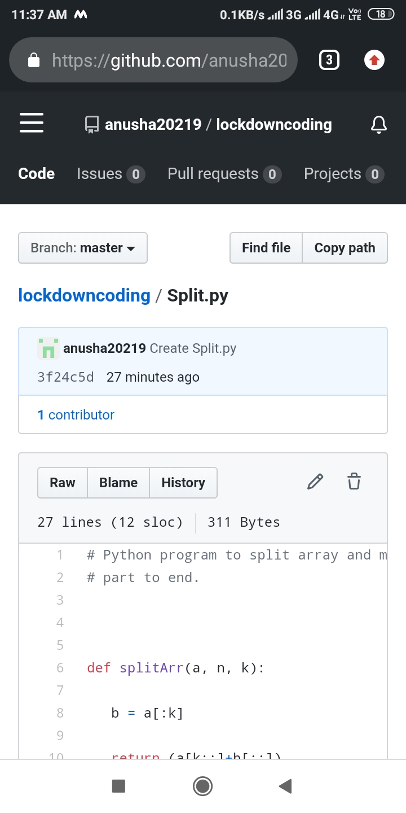Problem statement 01: Python Program to Split the array and add the first part to the end There is a given an array and split it from a specified position, and move the first part of array add to the end.

Problem statement 02:

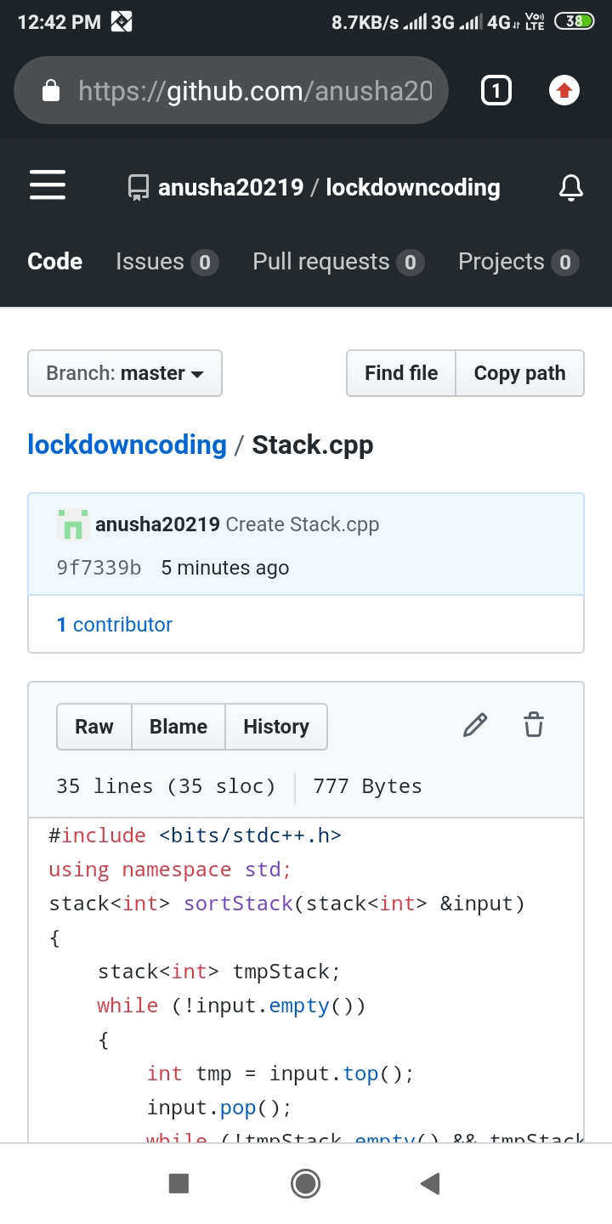 Write a C Program to Sort a stack using a temporary stack.